The following documentation is a pictorial guide of how to make and how to review a pull request.

Making a Pull Request

Select the pull request tab

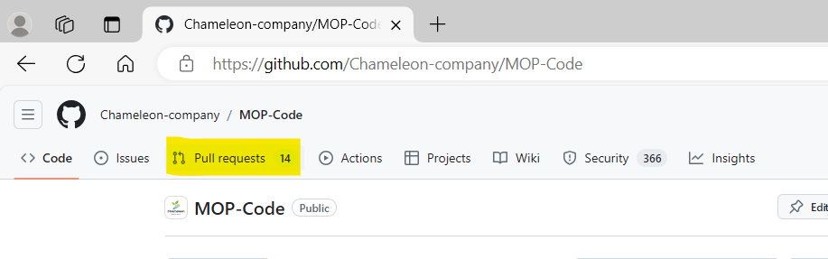

Select open new pull request
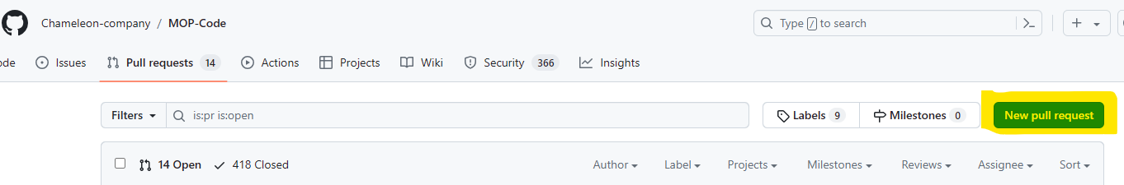

Select your branch from the drop down list in “compare”

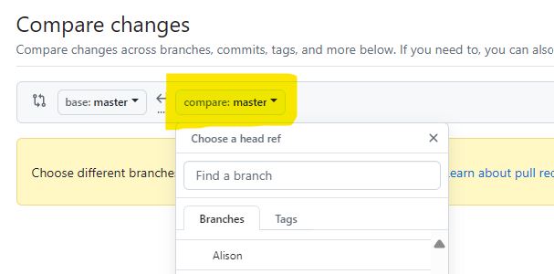

Select “create pull request”

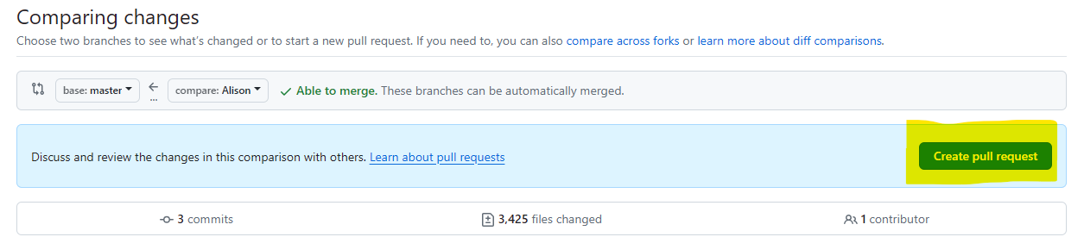

Add title and description for your pull request
Title must include which team you are (DATA SCIENCE or WEBDEV)
Name of what you are working on (This should match what is on your Trello card)
Percentage of completion of your use case from Trello
Description must include reason for pull, e.g. use case completed, Sprint 1 pull request.
Description must include a list of the changes that have been made to your folder since last making a pull request.

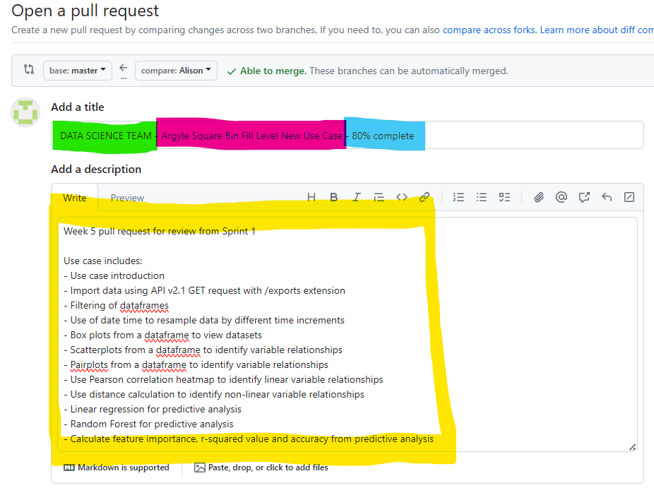

Select reviewers and choose 2 reviewers
One reviewer can be any member of your team, the other MUST be a leadership student.
You should message students fist to check if they are happy to review for you. You can find a list of GitHub user names to add reviewers on the Melbourne Open Playground team list in Teams.

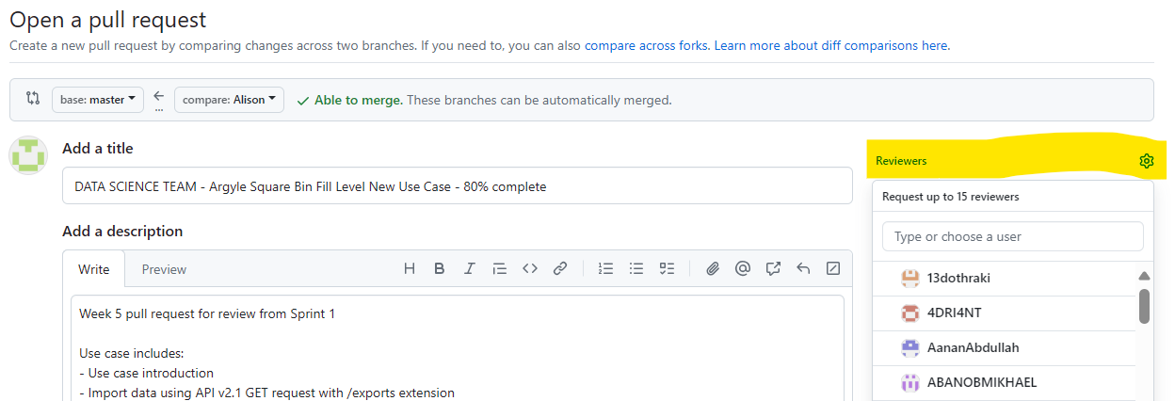

Check you have added two reviewers
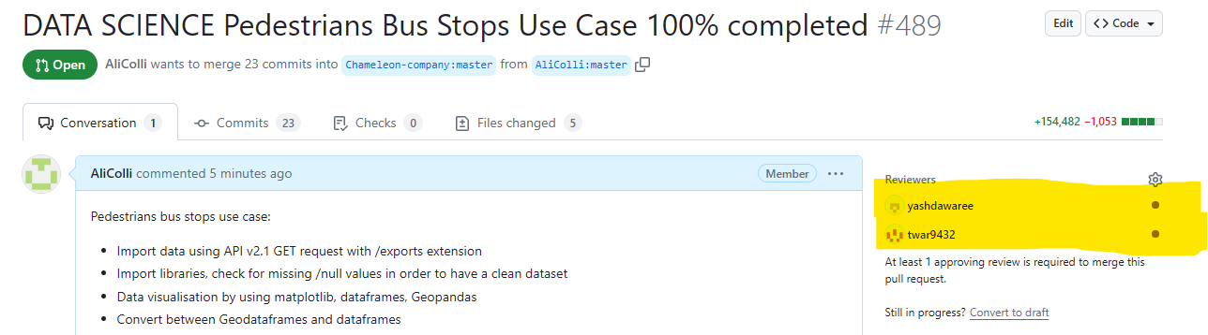

Create your pull request
Create your pull request by pressing the green “create pull request” button
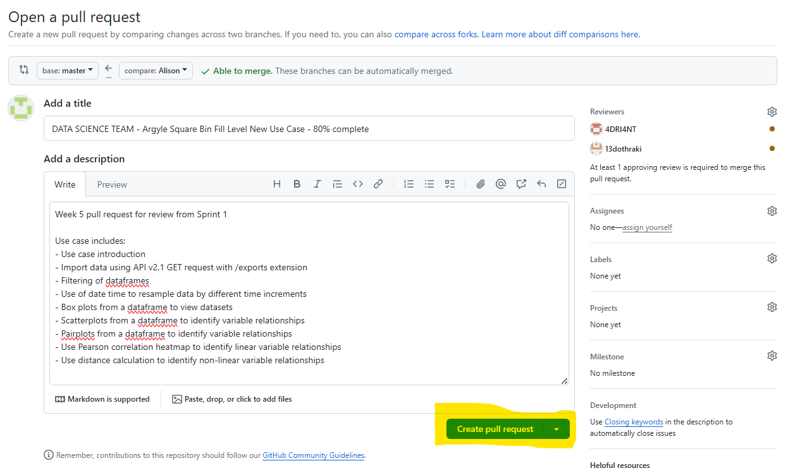

After Making a Pull Request

Check your emails
You will be emailed when your pull request receives comments or approvals.
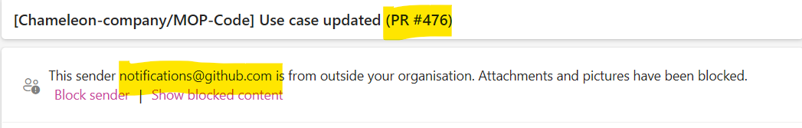

Check GitHub Conversation for Feedback
After reviewing, your team members will leave you feedback in GitHub.
Open your pull request, and scroll down to the comments section to see this. If you need to make changes you will need to do so in your IDE and then push to GitHub again.
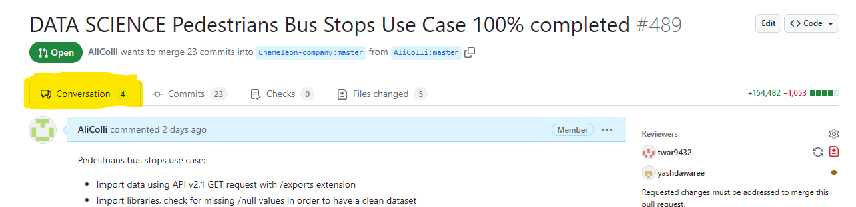
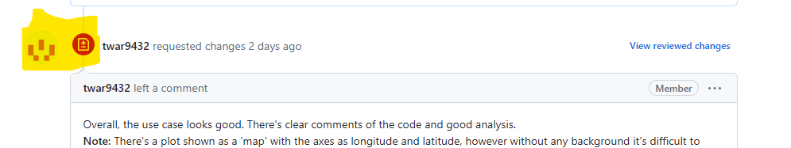

After making changes
Once you have updated your code and pushed again you will see a new comment automatically generated
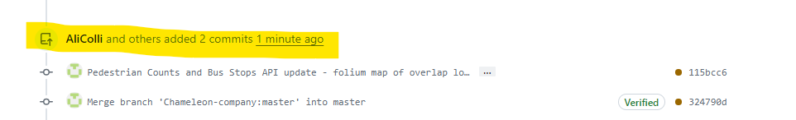

You will need to also add a comment to email your reviewers so that they know you have updates your work and that it is ready to be re-reviewed.
Be sure to write @ next to their GitHub name so they receive an email notification.
Be sure to press the green “comment” option to keep your pull request open.
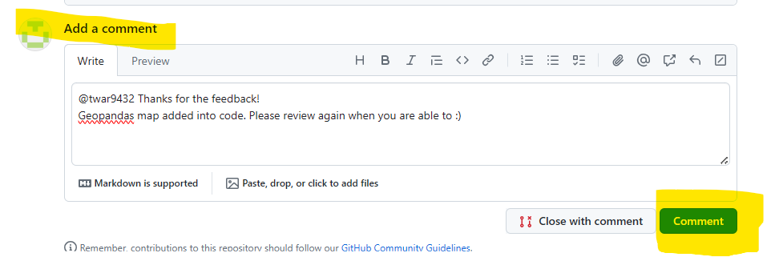

Check review status
Check both reviewers have approved your pull request. Look for green ticks against reviewers names
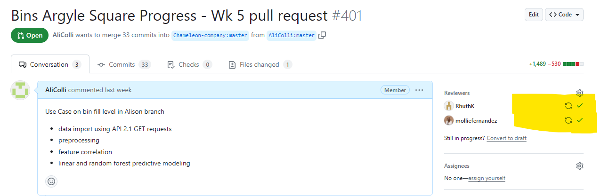

Merge pull request
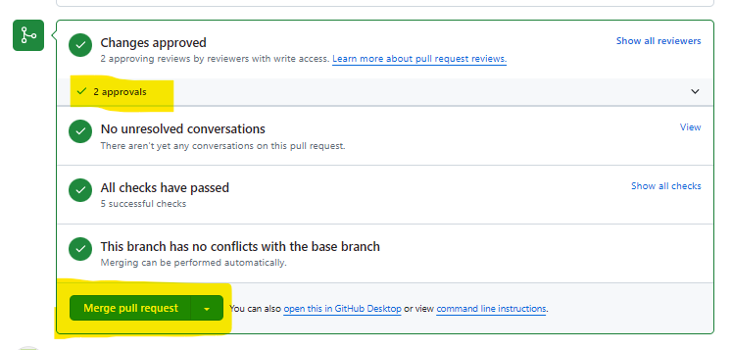
Once you have two approvals, Merge your pull request!

Reviewing a Pull request

View open pull requests
On GitHub, select “Pull requests”
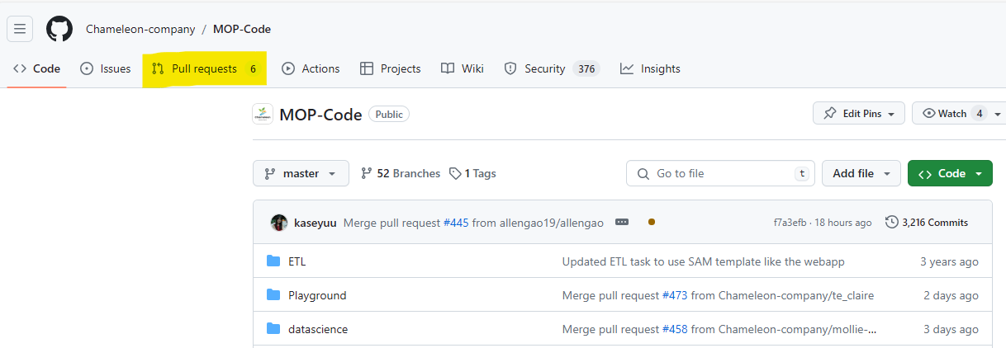

Select a Use Case to review
Select the “Reviews” tab and the “Awaiting review from you”
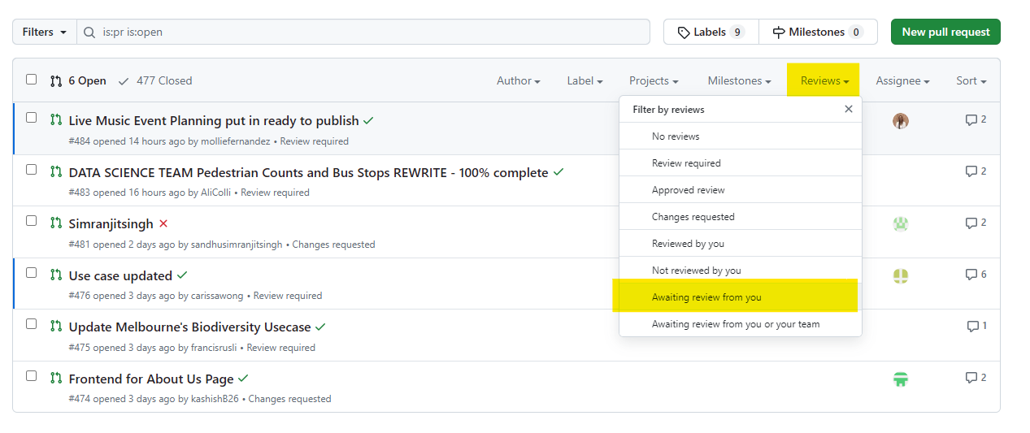

OR

Check your emails for review requests
Follow the link to the use case from your email


View the Use Case
When the use case is open, first thing, and the most important thing is to check is whether there is an infinity number of files being changed. If the request is for an infinity number of files to be merged, please do not approve this pull request, and let the requestor know to review this and redo the pull again.
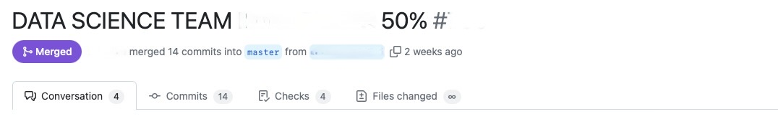

A correct pull should look like below, showing a reasonable number of files changed.
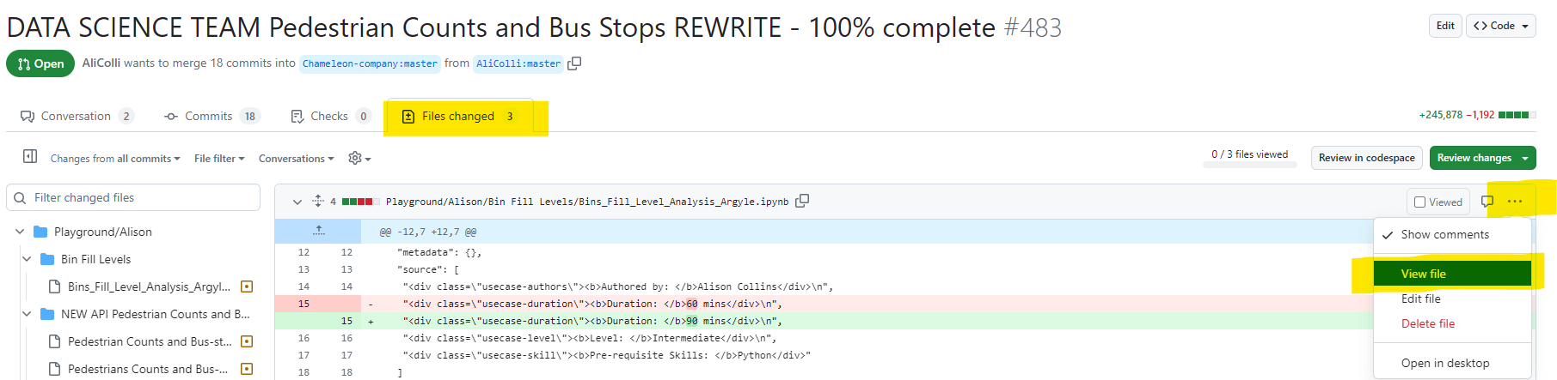

When the use case is open, select the files changed tab. If the use case is large, you will get a load diff alert. In this case, select the three dots on the right hand side and go to view file.


Pull Request Review Checklist
This checklist is designed to ensure consistency, quality, and adherence to standards when reviewing GitHub pull requests. Each item below should be reviewed carefully before approving a pull reuest. Use the heading of each checklist item and write down your comments if the use case has met requirements from the checklist.
Dataset Import
– The dataset is being accessed via API v2.1 to pull data from the Melbourne Open Data portal.
– API key must NOT be visible
– If an external dataset is used, a csv version of the file must also be uploaded to the repository
Instruction on API Key
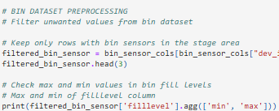
Code Quality & Readability
– Code must be well-structured and easy to understand
– Comments must have a space and capital letter for first word
– Variable names are meaningful and self-explanatory.
– Appropriate inline comments and documentation are included where necessary.
– Required libraries are imported at the beginning of the notebook.

Use Case Naming Conventions
– Use case name must follow the correct standard. Use this below tool and follow the instructions to rename the code file and your use case on MS Planner:
Use Case Naming Tool

Pull Request Location
– Use case has been submitted under the correct folder (MOP-Code – Playground)

Language
– The content is free from major spelling or grammar issues.
– Australian English spelling is used throughout (e.g., “standardisation” instead of “standardization”).

Visualisation
– All visualisations must have proper legends, labels and interpretations

Tutorial Quality
– The use case is written as a clear, step-by-step guide.
– Insights, libraries, and tools used are clearly described.
– The content is educational and accessible to new users exploring open data.

Use Case Template
– The correct Use Case Template has been used:
Use Case Template

Troubleshooting viewing:

If the Use Case or parts of it (graphs, tables, folium maps) will not render on GitHub, copy the link from the GitHub and open in https://nbviewer.org/

Select the files changed tab, three dots on the right and then view file
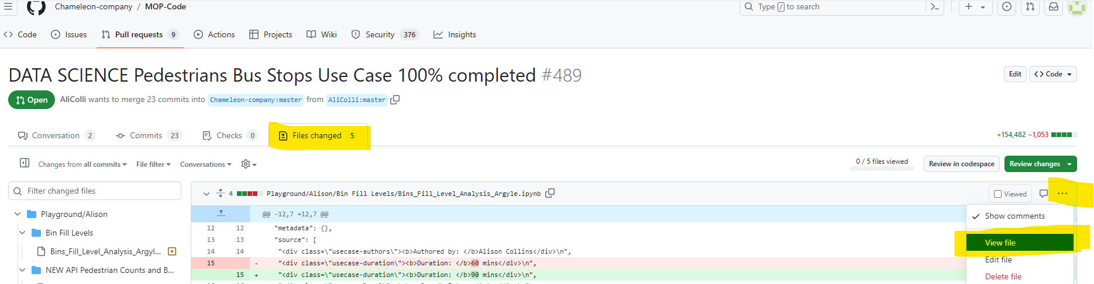

Copy the address bar
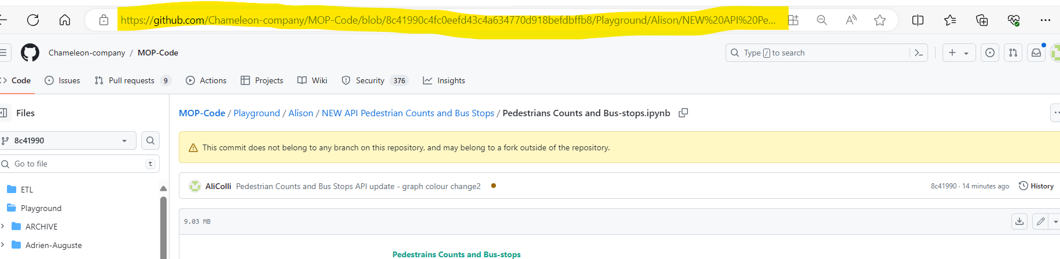

Paste into https://nbviewer.org/ and press go
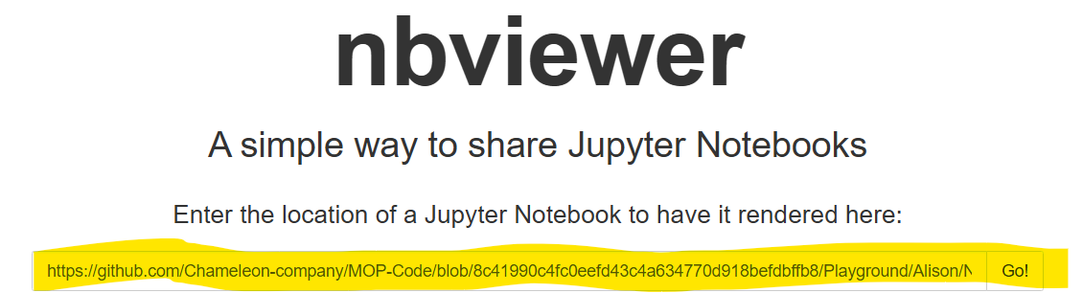

Review statuses:
Post your review of the pull request in one of these 3 statuses:

Comment: Submit general feedback without explicitly approving the changes or requesting additional changes.

Approve: Submit feedback and approve merging the changes proposed in the pull request.

Request changes: Submit feedback that must be addressed before the pull request can be merged.

Further reading
Capstone Pull Requests: 5. Navigating Pull Requests on GitHub | Capstone (verdant-raindrop-f3e404.netlify.app)
Capstone Reviewing Pull Requests: 6. Reviewing Pull Requests | Capstone (verdant-raindrop-f3e404.netlify.app).

Author
Alison Collins, 2024
Katrine Chan, 2024 v2
Jenny Nguyen, 2025 v3

